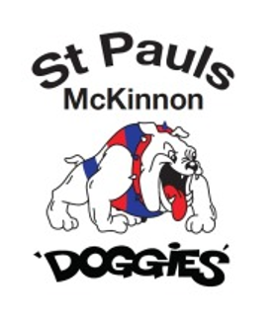
St Paul’s McKinnon JFC
Incident Reporting Procedure

Overview
This procedure has been developed to ensure that all complaints about inappropriate behaviour described in this policy are addressed sensitively, consistently, fairly, and confidentially at St Paul’s McKinnon (club).

A complaint may be reported about an individual or group behaviour informally or formally. It may be about an act, behaviour, omission, situation, or decision that someone thinks is unfair, unjustified, unlawful and/or a breach of this policy.

A complaint should first be reported to the Club’s nominated Child Safety Officer, who will be knowledge on the correct process to take.

Internal Procedure:

- Self-Resolution

Self-resolution may be appropriate where the alleged harasser or bully is oblivious to the impact of their behaviour towards the complainant. If the complainant feels it is appropriate, they can attempt to resolve the issue directly with the alleged harasser without the assistance of a member of St Paul’s McKinnon club representative or the nominated Child Safety Officer, by directly speaking to the person/s involved and asking them to stop the offensive behaviour immediately.

Resolve the Complaint Informally

Informal assistance may be appropriate where the complainant is not sure how to handle the problem and want to talk confidentially about the problem or the problem continues after the complainant has tried to approach the person/s involved. If this is this is the case, the individuals/s should talk with their nominated Child Safety Officer.

Informal procedures that may be adopted could include the following:
- Provide possible options/methods for the complainant to resolve the problem and/or make a referral to an appropriate person to help the complainant resolve the problem e.g. CSO;
- Explain the how the SMJFL complaints procedure works;
- Act as a support person;
- Privately speak with the alleged offender on behalf of the complainant; and
- Inform the relevant government authorities and/or police if required by law to do so.

Resolve the complaint formally

Formal procedures may be appropriate where informal procedures have been ineffective, the complaint involves serious and/or criminal allegations or the complainant wishes to make a formal
complaint from the outset. Formal complaints can be lodged with the clubs nominated Child Safety Officer using an Incident Report Form (available on the club website).

If the complaint is about a St Paul’s McKinnon member or the Child Safety Officer to whom the incident would normally reported, a report can be made to the SMJFL Child Safety Officer. If the club Child Safety Officer is unsure how to proceed, they will escalate the matter to the SMJFL Child Safety Officer.

Both parties involved in a formal complaint have a number of rights and responsibilities which are detailed below:
Complainant’s Rights | Respondent’s Rights
- Have the complaint investigated and if necessary conciliated  - Have support/representation if requested  - Express views and opinions without intimidation from others  - Discontinue a complaint  - Have situations remedied  - Privacy | - Have natural justice  - Have support/representation if requested  - Not be discriminated against  - Not be dismissed unfairly, harshly or unreasonably  - Not be defamed  - Privacy

A formal procedure will be followed as appropriate for each individual complaint which may include one or more of the following steps:
- Document full information from the complainant about the complaint and how they want it resolved;
- Put the information received from the complainant to the person/people that the complaint is about and ask them to provide their side of the story;
- Decide whether enough information has been obtained to determine whether the matter alleged in the complaint did or didn’t happen; and/or
- Determine what if any, further action to take. This action may include appointing a person to the investigate the complaint, referring the complaint to an informal or formal meditation session and/or referring to complaint to the police or other appropriate authority.

Appeal Process

If the internal complaints processes set out in the Policy do not achieve a satisfactory resolution/outcome, or if the complainant believes it would be impossible to get an impartial resolution with the Club or the SMJFL, an external agency such as The Equal Opportunity Commission may be contacted to assist with resolution.

External Procedure:

There may be range of external options available depending on the nature of the complaint. In the case of harassment or discrimination advice can be sought from The Equal Opportunity Commission without being obliged to make a formal complaint. In the case of serious complaint relates to an allegation of child abuse the matter will immediately be referred to the police or relevant state government authority.

Police or Government Authorities

Where an incident or suspected incident is of a serious enough nature as to be considered child abuse, the matter will be escalated to the police or relevant government authorities. Child abuse relates to children (a person under 18 years old) at risk of harm, usually by adults, sometimes by other children, and often by those they know and trust. It can take many forms. Children may be harmed by verbal, emotional abuse, physical actions and by people failing to provide them with basic care.

All allegations of child abuse will be dealt with promptly, seriously, sensitively and confidentially. It is a legal obligation that anyone who is reasonably suspects that a child has been or is being abused by someone within our sport, or by his/her parents/guardians, must report it immediately to the police or relevant government agency, and the St Paul’s McKinnon Child Safety Officer (CSO). The St Paul’s McKinnon Child Safety Officer (CSO) will not attempt to investigate, mediate or conduct any hearing into any allegation of child abuse as this it he role of the police and the relevant government agency.

The following diagram explains the informal complaint reporting procedure:
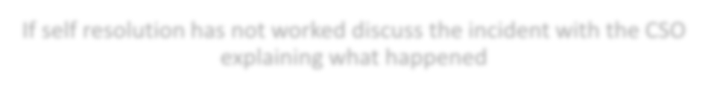
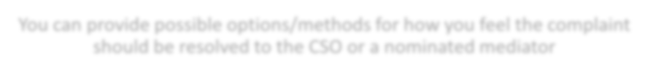
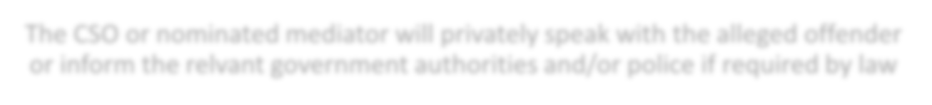
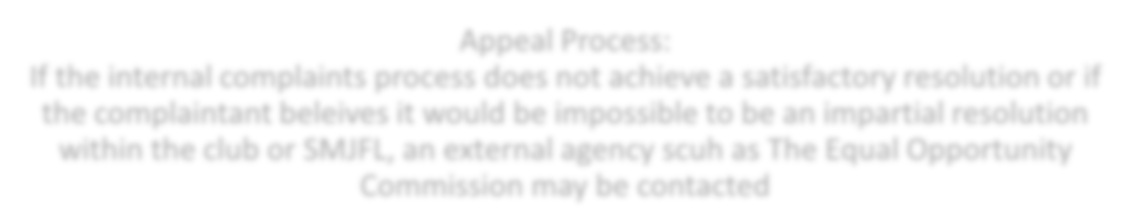
Informal Procedure
Self-Resolution: Attempt to resolve the issue directly with alleged harasser
by speaking directly to the person involved and asking them to stop the offensive behaviour
If self-resolution has not worked discuss the incident with the CSO
explaining what happened
You can provide possible options/methods for how you feel the complaint
should be resolved to the CSO or a nominated mediator
The CSO or nominated mediator will privately speak with the alleged offender
or inform the relevant government authorities and/or police if required by law
Appeal Process:
If the internal complaints process does not achieve a satisfactory resolution or if the complainant believes it would be impossible to be an impartial resolution within the club or SMJFL, an external agency such as The Equal Opportunity Commission may be contacted

The following diagram explains the formal complaint reporting procedure:

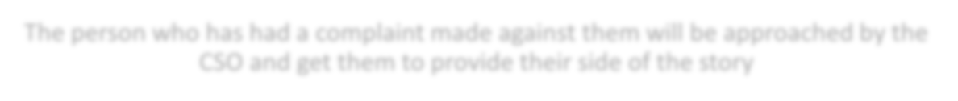
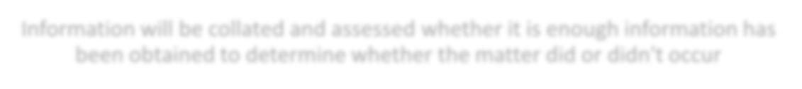
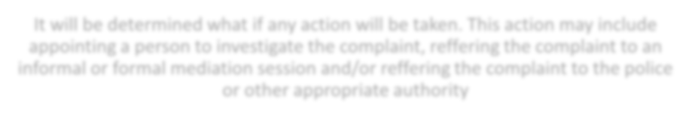
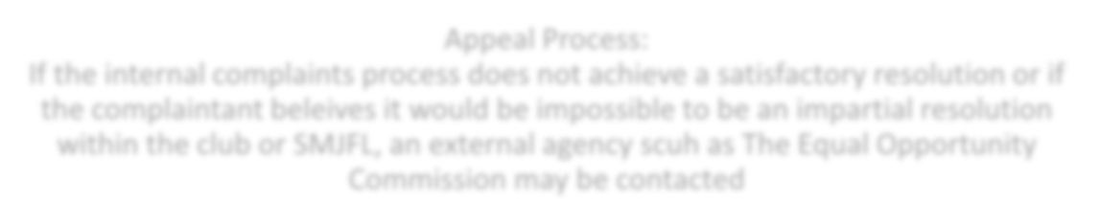
Formal Procedure

Document full information regarding the incident and how you would like it to be resolved

The person who has had a complaint made against them will be approached by the CSO and get them to provide their side of the story

Information will be collated and assessed whether it is enough information has been obtained to determine whether the matter did or didn't occur

It will be determined what if any action will be taken. This action may include appointing a person to investigate the complaint, referring the complaint to an informal or formal mediation session and/or referring the complaint to the police or other appropriate authority

Appeal Process:
If the internal complaints process does not achieve a satisfactory resolution or if the complainant believes it would be impossible to be an impartial resolution within the club or SMJFL, an external agency such as The Equal Opportunity Commission may be contacted
Updated By: Dana Forte
Approved By: Aron Newboult
Endorsed By: SMJFL
Date for Review: March 2023

